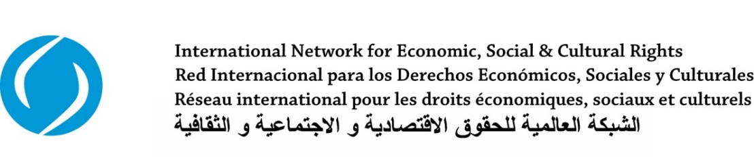

WORKSHOP REPORT

“Exchanging experiences and strategies in order to further the guarantee of Latin American women’s economic, social and cultural rights”

(November 11 to 13, 2014, Mexico City, Mexico)
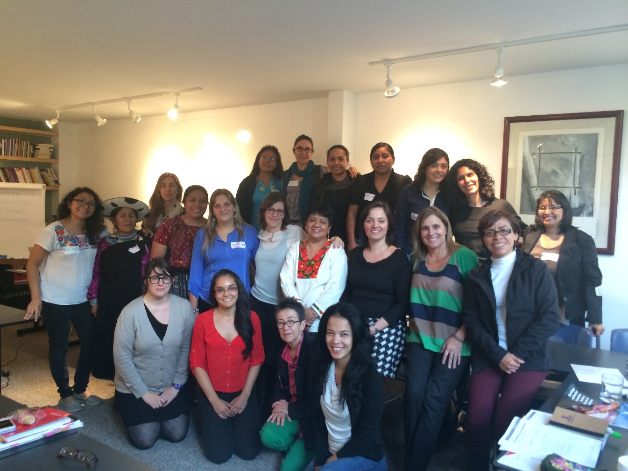
CO-ORGANIZERS
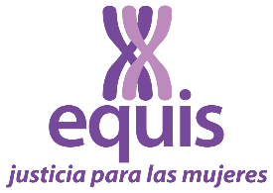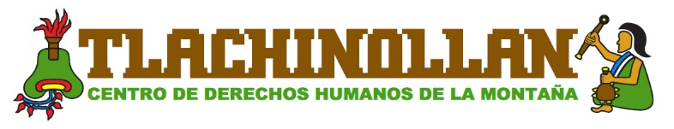

WORKSHOP OVERVIEW

From 11-13 November 2014, 25 women, activists and leaders in human rights across Latin America, gathered in Mexico City to participate in the workshop ‘Exchanging experiences and strategies in order to further the guarantee of Latin American women’s economic, social and cultural rights’. This meeting of the Working Group on Women’s Economic, Social and Cultural Rights (WESCR WG) of the International Network for Economic, Social and Cultural Rights (ESCR-Net) was co-organized by the Leadership Institute Simone de Beauvoir (ILSB), Equis: Justice for Women, and the Tlachinollan Human Rights Center, with input from WESCR WG Members and the support of the ESCR-Net Secretariat. The WESCR WG was particularly grateful to ILSB for hosting the meeting.

The workshop constituted a component of a wider project being coordinated by the WESCR WG over the next three years. The objectives of the workshop and the project more broadly are as follows:

- To facilitate discussion on, and develop capacity with respect to, the use of international human rights mechanisms to ensure the enjoyment of women’s economic, social and cultural (ESC) rights in practice, with a particular focus on the Optional Protocol to the Convention on the Elimination of All Forms of Discrimination against Women (OP-CEDAW), and the International Covenant on Economic, Social and Cultural Rights (OP-ICESCR).
- To foster greater awareness (both in international spheres as well as at a grassroots level) regarding the implementation of women’s ESC rights as a key strategy in improving substantive gender equality and eliminating poverty, with a focus on UN bodies and processes (including the post-2015 development agenda).
- To deepen the development and consolidation of a regional and ultimately international network of lawyers and activists working on women’s ESC rights, able to facilitate ongoing learning, solidarity and collective action.
- To identify issues of common concern and potential areas for collective action at the regional and international level.

The OP-ICESCR and OP-CEDAW represent an enormous opportunity to advance the protection of women’s human rights, through the identification and addressing of the massive challenges that women continue to face in the enjoyment of their ESC rights in Latin American countries. It is essential that organizations and activists create spaces to discuss potential strategies for using these international mechanisms.

This report outlines the following outcomes of the workshop:

- The mutual exchange of experience, indicating key issues and challenges faced in the participants’ work on ESC rights
- Strategies for using international mechanisms for justice
- Tactics for broadening and strengthening current work

1. MUTUAL LEARNING AND SHARING OF EXPERIENCES

The participants collectively identified the following 10 key obstacles to women’s full enjoyment of ESC rights:

- A lack of culture and education regarding human rights, which is perpetuated by patriarchal systems;
- Racism, discrimination, inequalities and violence directed particularly at indigenous, poor and peasant women;
- A lack of women’s autonomy, with autonomy understood as a broad and substantive social and political power that allows women to be subjects and to seek spheres of political power and autonomy including on a corporal level;
- The criminalization of protest;
- Spaces of decision making characterized by violence and a lack of women’s participation;
- Barriers to the right to access, live on, and own land;
- The privatization of public resources;
- An exhaustion of options in terms of the strategies used by participants, such that there is a need to rethink them and to work at local, regional and international levels in order to strengthen the demand that women’s rights be fulfilled;
- Precarious resources and funding for work with participants’ organizations, as well as for political work; and
- Access to justice (i.e. money, knowledge of legal systems, acceptance of cases, etc.).

Participants shared experiences from the work they are carrying out to protect women’s ESC rights in their countries. Over the course of these exchanges, participants identified similarities in relation to the challenges and regional themes that women from different countries must confront. In addition, they analyzed the ways that different groups confront obstacles to their work, as well as the regional and international political processes that impact the regional context. Given that the current context is one of enormous challenges confronting women who are trying to protect their ESC rights in Latin American countries, participants reported great value in ensuring space for organizations and individual activists to exchange strategies regarding the use of these international mechanisms.

An overview of issues discussed follows:

- Participants engaged in debates on the issue of women’s access to land and property. Although there are no laws preventing women from enjoying these rights, the reality is very different. Historically, due to patriarchal societies which encourage men to be the head of the family, most of the women have not been owners of land, and when they were, key decisions were frequently taken by men. Most women producers have not held property deeds, consequently experiencing constant vulnerability in relation to survival and life on the land. In addition, participants emphasized the practices of privatizing public resources and outsourcing natural resource extraction to transnational companies. The need to address these issues is becoming more and more urgent, as they cause displacement and evictions across large areas in the name of ‘development’. It was argued that this scenario affects peasant women in particular, given that peasant economies are characterized by marked inequality, with women often in the weakest positions in the chain of production. Participants stressed the connection between territory, women, and their human rights, given that rights such as food security, health, housing, and culture, as well as autonomy and the right to participate in decision-making processes, are jeopardized when women do not have access to land or territory.

“…women do not need a discourse that explains their situation to them, because they are living it; women are the weakest link in the chain of production, the ones who have to manage a series of obligations related to daily life. The idea of living in zones of armed conflict may seem unfathomable to many, but Latin America is a militarized region. Armed conflict has a direct impact on women given the reality of dispossession of land and sexual violence”

- Human rights issues regarding the care economy were also identified as common to the entire region. Women’s roles within the home and with respect to their reproductive capability are complicated by the reality that women lack economic autonomy. Attention was also brought to the different forms of violence that women experience, including in connection with armed conflict (both in terms of dispossession of land and sexual violence), obstetric, and institutional violence.

“… we do not know what our rights are; we aren’t even aware that, as women, we have rights. What are strategies for improving entire societies, as well as women’s lives?”

- The participants stressed the challenges in accessing justice for women who had experienced violations of their human rights, seeking to secure changes to laws, policies and practices. Factors leading to a lack of access include: inadequate resources throughout the region; judges and authorities who have a very restrictive and narrow conceptualization of women’s ESC rights; the structural difficulties and other issues causing a huge separation between legislation and implementation (despite the fact that the majority of Latin American countries have ratified relevant international conventions, and at least several countries have comprehensive rights frameworks).

“… there are 30,000 people who have been disappeared in Mexico, and it is women who are looking for their family members. These are poor, dispossessed women. They clean houses so they have the bus fare to search for their loved ones. This shows how violence is creating greater poverty”.

- The defense of ESC rights using a feminist perspective was presented by some participants as a way to unearth the entire model of capitalist development, a model that actually creates poverty given that it is predicated on the exploitation of people’s labor, particularly women’s. Participants raised the issue of grave abuse against women human rights defenders, such as the criminalization of their actions. In 2012, it was revealed that, without exception, in Mexico, Honduras, Guatemala and El Salvador, it was women defending land and natural resources who faced the most aggression from different actors (State and non State actors). They endure forms of collective abuse when, for example, they oppose a mining company or transnational corporation in order to defend their territory. Increasingly, women must band together as a matter of fundamental protection and self-care.

“… women in Mesoamerica have had a positive experience that demonstrates solidarity; when another woman has faced violence, we have come together en masse to make our voices heard and protect her”.

- Another key issue that emerged was the racism and discrimination on the part of state institutions towards indigenous women and girls in diverse contexts. All participants, especially those from rural areas and indigenous communities, condemned the difficulties encountered with respect to participation in decision making, such as in relation to the defense of territory, water, life, food security, rights of the commons and traditional knowledge. At the local level, the existence of agrarian conflict was noted in many areas, in connection with the lack of recognition of traditional forms of governance and autonomy. At times, both states and human rights organizations use a discourse that criminalizes indigenous people for customs and traditions that harm women, causing ruptures in the unity of indigenous peoples. Participants noted that, while there are collective norms that negatively impact indigenous women that need to be addressed, generalizations should be avoided. Furthermore, several governmental programs targeted at indigenous populations did not involve the consultation of indigenous women.

- Another point underlined was the common challenge constituted by the co-option of the human rights discourse by various actors, including international financial institutions, the private sector and transnational corporations. The tendency is one of depoliticization that leaves the human rights discourse devoid of meaning. Whilst human rights documents contain more and more references to girls, women and indigenous people, in reality these groups are treated as objects of investment, rather than as citizens. Participants noted that it is critical that we develop another language, and rethink how we use human rights mechanisms when our counterparts are operating with a different conceptual understanding.

- Finally, participants asserted that a certain inherent weakness of the human rights system must be acknowledged, not just in Latin American countries, but also globally. For example, human rights are not fully visible within the post-2015 process. The post-2015 objectives are configured such that a human rights perspective is not central, and this will have implications for how development policies are implemented in Latin American countries. The participants commented on the extreme disconnect that exists between international bodies and the extent to which women are able to access these spheres, and actual implementation. In the 20 years since the Beijing Conference, there is an immense divide between the formal recognition of women’s human rights and women’s concrete gains. There has not been adequate progress in regards to justiciability. Participants expressed that the current system wants to demonstrate the separateness of different rights. Whilst it is important to establish priorities in terms of public policy, human rights are all equally important and highly connected. Feminism may be the key to combating this separation.

2. STRATEGIES FOR USING INTERNATIONAL MECHANISMS

Workshop sessions covered the following concepts and international tools, as a basis for strengthening intersectional analysis and effective advocacy of women’s ESC rights:

- The concept of substantive equality: by using a framework of substantive equality to analyze violations of women’s rights, we broaden our understanding of violations and of the enjoyment of human rights in practice. This is true both in relation to the specific context of a violation, as well as broader structural, cultural and social factors.
- The OP-CEDAW mechanism: participants deepened their knowledge regarding its framework and operation, in the context of the Convention on the Elimination of All Forms of Discrimination against Women (CEDAW), one of the most comprehensive human rights conventions that currently exists in the UN system. The entry into force of OP-CEDAW created an individual complaints mechanism connected for violations of the rights contained in CEDAW. For women in the States that have ratified it, OP-CEDAW allows for a review of cases by a specialized independent committee incorporating a perspective focused on gender and women’s human rights, therefore making the implementation of CEDAW more effective. The Committee on the Elimination of Discrimination Against Women can examine cases and provide detailed assessments of a law or national policy in concrete situations, as well as providing guidance to states regarding more general measures that ought to be taken to prevent further similar violations.

Throughout the workshop, participants contemplated the advantages and disadvantages associated with using international OP mechanisms, making the following comments.

- It is fundamental that women’s rights activists are familiar with the OP-CEDAW, existing jurisprudence, and the avenues opened in terms of demanding the fulfillment of women’s rights. Sometimes a narrative communicates much more than statistics and numbers. By using the OP-CEDAW, people who are still lacking political power can share their experiences.
- Participants emphasized that litigation is also an advocacy tool with the potential to empower people who have experienced violence. They cease to be victims and, instead, become subjects pursuing their rights.
- Litigation is just one tool of many, and should not be perceived as a magic solution, nor as a replacement for national law. It is a process that may involve a considerable time investment, and can demand the intense involvement of social movements and civil society in order to gain validity and force.
- International law can also offers direction to the rights movement, given the existence of diverse priorities and struggles against very powerful entities. Yet it is a tool that requires a long-term vision. It can take years to win a case, and even longer for the ruling to actually be implemented. As such, the goal of human rights litigation is not only to benefit specific victims, but rather, to bring about broad structural change.
- The implementation of a ruling can often be a tremendous challenge given that the Committees do not have the binding authority of a court. Rather, they can only issue recommendations, and the value that these hold in a given country is contingent upon that particular State, requiring diverse advocacy strategies oriented towards national policy and context. Not all governments recognize these recommendations to the same extent, and the types of reparation to victims can vary significantly.
- Another important aspect is the need to advance issues related to reparations grounded in a gender perspective. This does not mean a perspective focused on how reparations should be different for women, but instead, innovative thinking regarding what it means for the reparations process to be gender-based. This implies thinking about what impacts are generated and how for those receiving reparations, in relation to changes in laws and policies, in terms of precedents that incur cultural shifts in how these issues are perceived, in the symbolic value and meaning of women’s issues, and in creating precedents that are used in national courts and in conjunction with other international mechanisms.
- Participants insisted that litigation must be combined with other advocacy strategies. These strategies must be much broader and address the politics of mobilization, dissemination, etc. In Latin America, shadow reports have been used most extensively, as they provide spaces that are key in raising the awareness of the expert committee.
- Participants raised the following questions: why aren’t there more cases in Latin America? Should cases be brought to the Inter-American Human Rights System (characterized by excessive delays) or to international system? How can the two systems be brought into dialogue?

3. TACTICS FOR BROADENING AND STRENGTHENING CURRENT WORK

The workshop culminated with a series of proposals for collective work and strategies to utilize international mechanisms with the aim of guaranteeing Latin American women’s ESC rights with greater frequency, as well as broadening and strengthening the struggles spearheaded by women at local, regional and global levels.

The table in Appendix A outlines the additional strategies identified in connection with the international mechanisms to advance the ESC rights of women in the region. These proposals for action included measures on the following:

- Member-to-member training and education within the WESCR WG
- Providing resources to other women leaders
- Documentation of emblematic cases and the impact of such cases
- Implementation and advocacy
- Use of national and international litigation
- Forming alliances at the local, national, regional and global levels
- Development of/access to appropriate resources
- Enhanced communication and information-sharing

Participants reaffirmed that the WG WESCR is in an ideal position to advance such collective work; it possesses important characteristics necessary to continue to evolve as a space of solidarity and exchange dedicated to securing women’s human rights.

APPENDIX A: PARTICIPANT SUGGESTIONS FOR BROADENING AND STRENGTHENING CURRENT WORK

MEMBER-TO-MEMBER TRAINING AND EDUCATION WITHIN THE WORKING GROUP  - Education on mechanisms  - AWID mapping – Economic Justice Training  - Share the technical and political knowledge offered with organizational teams. Revisit the publications and their inputs | PROVIDING RESOURCESTO OTHER WOMEN LEADERS  - Support from organizations belonging to the network in providing training in different thematic areas  - Develop a training and education plan  - Empowering of women leaders | DOCUMENTATION, EMBLEMATIC CASES  - Accompany/mentor women in international forums  - Documentation of emblematic cases related to women’s ESC rights  - Systematize experiences and make them accessible such that dialogue and reflection can follow within the ESCR-Net teams
IMPLEMENTATION AND ADVOCACY  - Provide incentives for the creation of governmental bodies specialized in the implementation of the recommendations and rulings from international bodies (Committees/the Inter-American Court of Human Rights)  - Continue reflecting on and operationalizing other ways of doing this work in order to reduce the gap between the international and the local  - Tools for political advocacy (social movements, unity)  - Social and political mobilization | NATIONAL LITIGATION  - Via training and consultations on local litigation  - Include content on economic, social, cultural and environmental laws for consideration and to ensure the holistic content of women’s human rights  - Apply international instruments within national litigation as a means to gradually create higher standards for the protection of human rights | LITIGATION AND INTERNATIONAL COMPLAINTS  - Support organizations affected by violations to women’s economic, social and cultural rights with urgent action alerts  - Training on how to present a complaint to international entities regarding violations of economic, social and cultural rights  - Apply what has been learned in order to carry out international litigation strategies that allow us to demand ESC rights in international spaces given that the national level is more complicated  - Carry out preliminary mapping on the context and key actors in relation to the ratification of the OP-ICESCR
ALLIANCES (LOCAL, REGIONAL, NATIONAL LEVEL)  - Work as an allied collectivity  - Connect with the women’s working group in coordination with the network (resources)  - Enlist more movements and organizations dedicated to these types of actions  - Active participation in the ESCR-Net Working Group  - Use the alliance with the Network for specific issues related to ESC rights (for example, sexual and reproductive rights)  - Strengthen strategic alliances  - Collaborative work involving the working group on women’s ESC rights and the working group on strategic litigation  - Innovative regional strategies based on decolonial feminism (situate ourselves)  - Link the local, national and international scales (Post-2015) | RESOURCES  - Adequate financial resources to carry out work  - More resources on Financing for Development (FfD-2015)  - A need for mutual support, and resources so we can promote our activities in organizations resources | COMMUNICATION AND INFORMATION  - Information sharing on ESC rights with other local groups  - Make our actions effective for all women as a means to promote human rights in each of our organizations and in each country. Establish links or communication between all  - Establish communication in order to coordinate actions with other groups dedicated to promoting  - ESC rights on a local level  - Maintain constant communication with relevant networks  - Develop mechanisms for exchanging information related to our work and constant communication through sharing lessons learned with my colleagues  - Constant communication and dissemination  - Grassroots communities (NGOs as platforms)  - Utilize relevant information to strengthen international work  - Reproduce and share knowledge

APPENDIX B: LIST OF PARTICIPANTS (in Spanish)
PAIS | ORGANIZACIÓN | PERSONA
- Argentina | CELS | Edurne Cárdenas
- Brasil | Movimento dos Atingidos por Barragems | Neudicléia Neres de Oliveira
- Colombia | FIAN | Paola Romero Niño
- Colombia | ILSA | María Eugenia Ramírez
- Colombia  - (por skype) | CRR | Mónica Arango
- Ecuador | Coordinadora Andina de Organizaciones Indígenas | Carmen Lozano
- Estados Unidos | Secretariado RED DESC | Daniela Ikawa
- Guatemala | Asociación Q'ukumatz | Lorenza Laynes
- México,  - Leon-Guanajuato | Centro de Derechos Humanos Victoria Diez | Angeles López
- México, Chihuahua- Chihuahua | Cedhem | Arely Varela
- México, DF | Equis | Fátima Gamboa
- México, DF | Gire | Regina Tamés
- México, DF | ILSB | Valentina Zendejas
- México, DF | ILSB | Ximena Andión
- México, DF | Jass | Marusia López
- México, DF | Prodesc | Andrea Medina
- México, DF | Prodesc | Anahí Ávila Enciso
- México, Oaxaca | CIARENA AC | Dalí Ángel Pérez
- Paraguay | CLADEM | María Limpia Díaz
- Perú | Confederación Campesina del Perú | Elga Angulo
- Uruguay | AWID | Alejandra Scampini
- Uruguay | Secretariado RED DESC | Graciela Dede
- México | Consorcio Oaxaca | Fátima Ojeda

All of the cited information related to the different mechanisms, including CEDAW, the Optional Protocol, how to use the tools detailed in the conventions and legal precedents is in the guide Cómo Exigir los Derechos Económicos, Sociales y Culturales de las Mujeres, by ESCR-Net and IWRAW AP. Available at www.escr-net.org/es/node/365299. The English version is entitled Guide: Claiming Women’s ESC Rights Using OP-CEDAW and OP-ICESCR. Available at http://www.escr-net.org/node/365157.
The Optional Protocol is a treaty that can be ratified by those governments that are already parties to the Convention. It is qualified as optional because the governments have no legal obligation to ratify the Optional Protocol despite having done so for the Convention.

