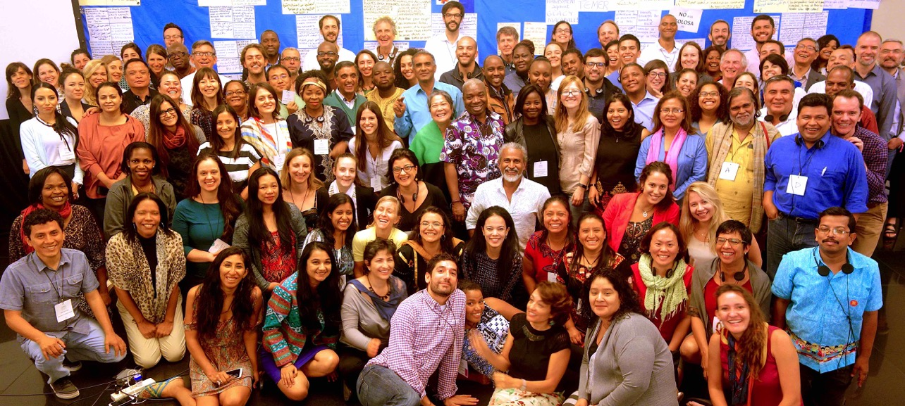
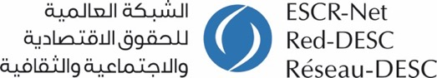

Towards collective action confronting common global conditions

Report from ESCR-Net’s Global Strategy Meeting 2016

I. Introduction

More than 140 representatives of social movements and civil society organizations from over 40 countries came together for ESCR-Net’s Global Strategy Meeting (GSM) in Buenos Aires, Argentina, from 15-19 November 2016. In reviewing the Network’s progress over the last three years and considering its future, members were guided by the overarching question: what transformative, collective action will ESCR-Net undertake to realize ESCR over the next 5 years, responsive to global conditions?

Since its conception, ESCR-Net has been guided by a member-led model of work based on building shared analysis grounded in the lived experience of people affected by ESCR violations, and advancing concrete, collective actions able to affect systemic change. This model has been shaped by core principles of regional diversity, the centrality of grassroots groups and social movements, and gender balance in leadership and intersectional analysis. At a time when dominant global systems perpetuate inequality, marginalization and injustice, members recognize the need to deepen common analysis of global conditions and work towards Network-wide objectives to coordinate joint action, drawing on the diverse strengths of members across every region.

During the GSM, members assessed their collective work via the network, deepened an analysis of socio-economic and political systems undermining the realization of human rights, and took important steps towards network-wide objectives and two-year working group action plans. Members affirmed the Common Charter for Collective Struggle (Charter), initiated by the Social Movement Working Group and developed with input from members of all working groups. The Charter articulated a series of common global conditions, as well as emerging points of unity, which could help to frame network-wide actions and campaigning. In doing so, members also affirmed the need to more fully integrate intersectional and gender analysis, foregrounding the understandings and leadership of those who have long experienced and resisted marginalization, impoverishment, discrimination and dispossession.

The GSM formed a key part of a longer-term process to shape the overall direction of the Network for the next five years, which began with reflections on current activities and global conditions, and which will culminate in a new strategic plan in mid-2017. Over the course of 2016, and with the guidance of the ESCR-Net Board – elected from and by members – ESCR-Net members engaged in a range of discussions and planning to prepare for the GSM. This involved the creation of an International Planning Committee, leadership from Working Group Steering and Planning Committees, wider Working Group discussions, and essential support from members based in Argentina. The resources committed to the GSM reflect the Network’s recognition of the importance of periodic, in-person gatherings to progress ESCR-Net’s mission to build a global movement to make social human rights and social justice a reality for all.

While generally aiming to strengthen cross-regional connections, solidarity and ownership of a renewed movement for human rights and social justice, in line with the overarching question stated above, the GSM aimed, to:
- Critically evaluate the Network’s progress in relation to its existing strategic plan;
- Deepen common analysis of shifting global conditions and forces impacting communities around the world and build consensus on where ESCR-Net is best positioned to advance systemic change through human rights, setting a new overarching strategic plan;
- Gather all working groups to refine objectives in line with the shared vision of members, evaluate existing work and target new areas of joint advocacy;
- Consider collective campaigns or positions to strengthen ESCR-Net as a member-led platform advocating the realization of ESCR; and
- Strengthen cross-regional connections, solidarity and ownership of a renewed movement for human rights and social justice.

This report provides a summary of the GSM discussions and key outcomes, contained in the following sections:
- Assessing the Network’s recent work...............................................................3
- Considering global challenges, opportunities and constructive practices........5
- Defining shared objectives to advance ESCR over the next five years............8
- Developing collective action within working groups........................................10
- Ensuring a safe space for human rights work................................................17
- Next steps.......................................................................................................18

II. Assessment of the Network’s recent work

The GSM offered an important opportunity to consider the key achievements, lessons and current priorities of the Network, which in turn formed a foundation for discussions about future collective work. This assessment emerged primarily through:

- Working groups reports: In the lead-up to the GSM, members assessed the impacts achieved and lessons learned from over the past three years via brief reports on corporate accountability, economic policy, monitoring, strategic litigation, women and ESCR, as well as ESCR-Net’s System of Solidarity. Highlights from these reports were shared by Working Group representatives during the opening session of the GSM.

- Institutional development report: The Board also provided an institutional development report, which described measures taken in recent years to strengthen member-led planning processes, reinforce core principles in practice, further develop the ESCR-Net secretariat, secure independent legal status (which took effect on 1 July 2016), renew the Board via elections that took place in November 2015, and secure diversified resources to support the Network’s collective work.

- Lessons from cross-Network collaborations: On the second day of the GSM, members considered recent forms of cross-working group and Network-wide action. In efforts to inform work towards shared objectives and deepening Network-wide collaboration, participants engaged in interactive panel discussions centered on the following examples:

Evolving efforts to advance human rights in relation to land and natural resources. In the context of a prior project on forced displacement, the discussion foregrounded the analysis and strategies of social movements in setting the direction for collective work. It also reviewed more recent efforts to incorporate a gender (and increasingly intersectional) analysis to ESCR-Net’s activities, highlighting projects to address the different and disproportionate impacts experienced by women with regards to land and natural resources. Previous collective projects and initiatives responding to this topic – including confronting the impact of the extractive industries and development projects, supporting the implementation of landmark decisions in relation to land displacement, and exploring the particular impact of ESCR violations on women – have involved members from multiple working groups.

Celebration of the successful conclusion of the Campaign for the Ratification of the Optional Protocol to the International Covenant on Economic, Social and Cultural Rights: Participants celebrated the key achievements and successful conclusion of the Campaign, while reflecting on the ways in which members across the Network acted together at all stages of the initiative. Following the formation of the International NGO Coalition for the Optional Protocol to the ICESCR in 2001, it coordinated a series of proposals to inform the content of the new instrument, including its applicability to all rights in the ICESCR, incorporation of the standard of reasonableness and effective rules of procedure. The Coalition, via the Campaign, supported peer-to-peer promotion of the new instrument among States, developed a set of resources and advocacy tools, and pushed for ratifications around the world. With its tenth ratification, the OP-ICESCR entered into force in May 2013, strengthening access to justice for persons in the States that have ratified the instrument, but also enhancing the significance of ESCR generally. Members also discussed the evolving nature of work promoting access to justice in connection with the Campaign. For example, various Working Groups have engaged in capacity building in various countries which connects the OP-ICESCR with the need for standards and practice to secure access to justice. Members from the Strategic Litigation Working Group also submitted a third-party intervention in the first case under the OP-ICESCR, providing the Committee with relevant international and comparative material to support a proper determination of the case, and influencing the practice of the Committee with respect to third-party interventions.

III. Considering global challenges, opportunities and constructive practices

The Common Charter for Collective Struggle

In the lead-up to the GSM, ESCR-Net’s Working Group of Social Movements and Grassroots Groups (SMWG) offered shared analysis about common global conditions, an emerging vision for forging unity across struggles, and initial points of consensus relating to shared demands for justice that might inform a global campaign in line with ESCR-Net’s mission. Following input received from members in various thematic working groups in June and July, 2016, the revised Charter addresses:

Common global conditions
The Charter outlines key trends that characterize the economic, political and social context in which members are working. These include impoverishment and dispossession amid abundance, as resources and productive capacity are concentrated into fewer hands. Members reject poverty as an inevitable byproduct of a global economy, decry the commodification of people and nature, livelihoods dispossession and the marginalization of women and criminalization of the poor. In doing so, they underscore their resolve to counter corporate capture of government institutions and to confront a corporate-police state “increasingly willing to use police and military to serve the interests of capital instead of people.”

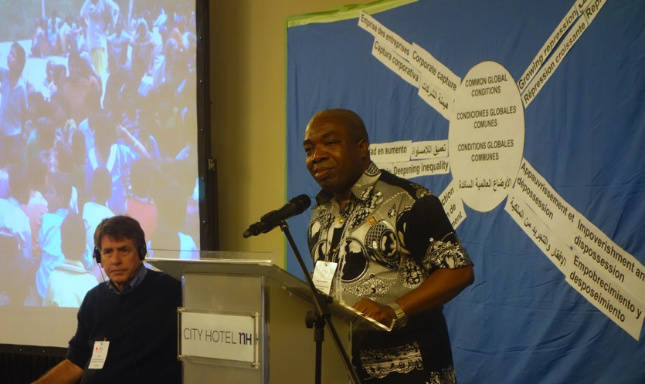
The Charter highlights deepening inequality and notes that immense economic inequality has often been perpetuated through gender stereotypes, racism and discrimination against minority groups, resulting in the disproportionate exclusion and impoverishment of women. These inequalities are further exacerbated by climate change and the deliberate/negligent degradation of ecosystems such as forests, rivers and oceans, which impact most severely on the poor.

Human rights defenders working to advance ESCR also face intensifying repression which has been bolstered by a wider politics that instigates fear and prejudice and characterizes human rights defenders as criminal, anti-national, extremist and otherwise illegitimate. In response, the Charter calls on ESCR advocates and social movements to take necessary solidarity actions and collectively confront the root causes that have prompted social movements to mobilize in the first place.

Emerging points of unity
The Charter highlights several points that serve as the basis of a deepened unity amongst advocates, organizations and movements and a foundation for the ambitious collective work that must take place in order to respond to the common global conditions mentioned above. These include the shared effort to reclaim human rights and a commitment to deepen connections between struggles and conceptualize these as part of a global movement. Such a movement would, among other things, confront corporate capture and call on the governments of the world to recognize rights, with corresponding and legally binding obligations, and not merely aspirational “goals.” They would further question the drive for profit over the wellbeing for the great majority, and commit to advance the leadership of the poor and marginalized in effecting positive social change, based on their lived experiences. In addition, the Charter calls for the articulation and expansion of alternative models that affirm human dignity, insist on substantive equality, safeguard space of dissent and ultimately envision a common future.

The Charter as a foundation for discussions during the GSM

Following a presentation of the common conditions and shared challenges detailed in the Charter by members of the SMWG, members spent time together – via five bilingual, cross-regional, cross-Network groups – to connect the Charter analysis to the challenges, opportunities and constructive practices they are experiencing in their own work. Please see ANNEX A (p. 20), which aggregates the inputs generated by each small group, for the results of this exercise.

Key Outcomes

During the concluding session, members participating in the GSM affirmed the Charter as a basis for shared analysis and a guide for collective work for the coming period. Via the Charter, members reaffirmed the need to ground their work in the lived experience of those affected by and resisting impoverishment, dispossession and marginalization. As initially encouraged by the SMWG, in connecting these struggles and exploring root causes, the Network adopted a systemic analysis of the global economic, social and political conditions hindering the realization of human rights for all people.

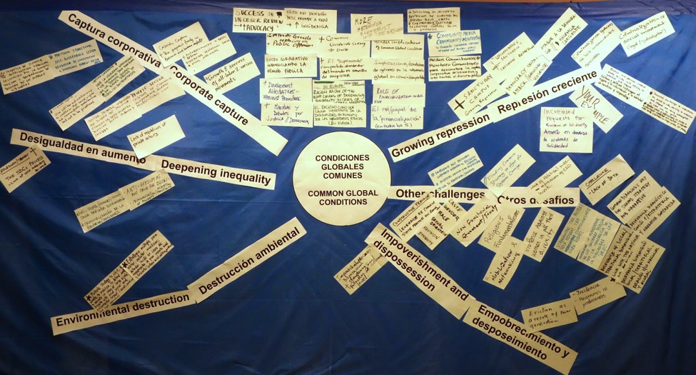

Significantly, the Charter also calls attention to the disproportional impacts of the above-mentioned conditions on women and members of certain groups. In this regard, key economic, political and cultural trends have pushed women, in particular, into vulnerable situations of employment; exacerbated women’s exclusion from control or ownership over land, financing and other productive resources; compromised their access to essential services, such as health care and education; and rendered their economic contributions invisible. Similarly, the Charter acknowledges the historic oppression and exploitation experienced by differently-situated people. In affirming the Charter, members underscored their commitment to promoting substantive equality for women and other marginalized groups and attention to an intersectional analysis in all areas of ESCR-Net’s work.

Members also endorsed the emerging points of unity described above and expressed a commitment to establish a process to develop coordinated Network-wide actions, potentially including a global campaign, which respond to the urgent need for systemic change and draw on the strength of the Network’s collective voice.

IV. Defining shared objectives to advance ESCR over the next five years

Towards Network-wide shared objectives

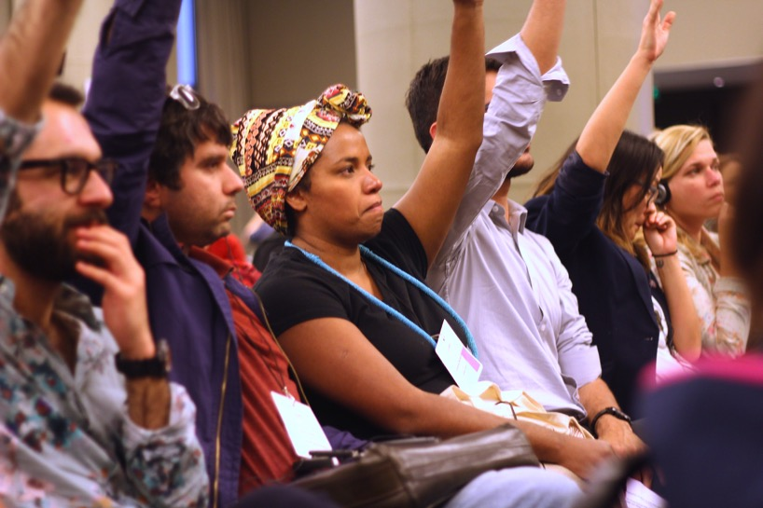
On the third day of the GSM, members sought to address the overarching question: “What transformative, collective action will ESCR-Net undertake to realise ESCR over the next 5 years, responsive to global conditions?”

Through a facilitated process based on input from each member, initial responses were shared and discussed in five small groups (which were purposely bi-lingual, cross-working group, and cross-regional). Similar responses were grouped together by members in clusters, and each cluster was given a working title. These titles, from each of the five small groups, were then grouped into new clusters by representatives of each small group. In a full plenary process, each cluster was given an interim working title, responding to the workshop question and reflecting the main ideas or intention represented by the cards in the particular cluster.

Please see ANNEX B (page 29) for the images and transcribed results of the plenary process and each small group discussion.

Key outcomes
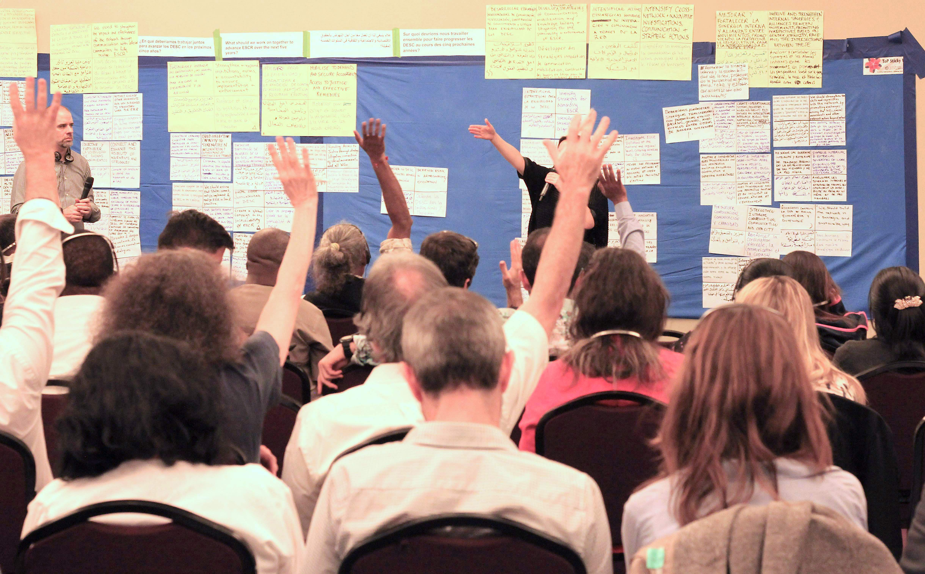
Across the top of the table are the working titles developed by during the plenary process. Under each working title are the title cards from the small group discussions that were clustered together based on similar ideas or intent.
These working titles will form the foundation for the Network’s agreed shared objectives, to be included in our forthcoming five-year strategic plan. Drawing on the understandings and commitments of the over 140 member representatives present, the results of this process represent an important step towards members collectively shaping shared objectives to guide joint actions in the coming period.

V. Developing collective action within working groups

Working Group discussion days

On the fourth day of the GSM, the Working Groups on Women and ESCR, Strategic Litigation, Corporate Accountability, Monitoring, and Economic Policy, in parallel meetings, considered the focus of their collective work for the next two years, reflecting both on global conditions outlined in the Charter and on the emerging shared objectives for the Network.

Each Working Group considered existing and new key action areas, and related specific projects/activities to advance these areas. In doing so, members discussed the extent to which the proposed action area responds to a key global challenge or opportunity, and the extent to which ESCR-Net is able to play a unique and valuable role in addressing these through collective work. Members also began to take into account the intended impact(s), the choices to be made given available time and resources, and potential opportunities for collaboration with other working groups and/or for contributing to Network-wide actions.

Key outcomes

Summaries of the discussions in each Working Group meeting are set out below:

Women and ESCR

Regarding priority substantive/thematic areas, three main action areas were identified: women’s rights and substantive equality in relation to (1) housing, land and natural resources; (2) sexual and reproductive health and rights; and (3) right to work. With respect to housing, land and natural resources, members expressed commitment to continued work, identifying sub-topics such as the impact of mega-projects on women’s rights, women’s access to housing rights in urban informal settlements and monitoring the new urban agenda and the Sustainable Development Goals at multiple levels. Concerning the right to work, members discussed projects including domestic work and gender-based violence in the workplace. On the topic of sexual and reproductive health and rights (SRHR), topics included violations affecting girls, SRHR education and access to safe and quality abortion services and contraception through activities such as joint lobbying of national governments and strategic litigation and advocacy. Focusing on these themes will allow a greater number of members to actively participate in the WG by contributing their expertise in relevant areas.

An additional action area was informed by a priority highlighted throughout the meeting to more fully infuse a gender and intersectional analysis and approach throughout ESCR-Net (which will in turn more broadly affect individuals and communities who are impacted by the work of the Network). Members articulated two aspects of this work: (1) collaboration with other working groups, for example on specific projects or activities and (2) integration of a feminist analysis across the Network. Members emphasized that both a gender/feminist approach and an intersectional approach must be part of these efforts. Specific activities to deliver on this priority area include: create a common charter towards a feminist perspective for the Network, conduct webinars on gender/intersectional issues and create a fact sheet on these issues.
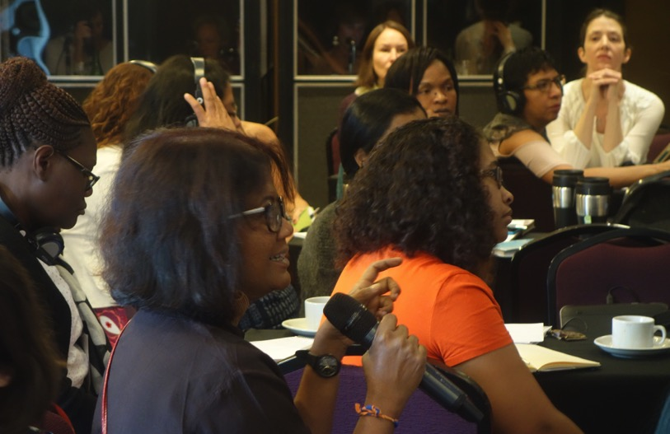

With respect to strategy and methodology, members discussed further developing current strategies to advance substantive equality broadly and in relation to the new substantive themes identified as priorities. For example, they expressed continued commitment to strengthen capacity to defend and advocate women’s ESCR through workshops and webinars as well as development and dissemination of materials. Additionally, building on and nuancing an existing strategy, members discussed leveraging members to act together to advance international standards on women’s substantive equality on ESCR and support implementation. Members emphasized the importance of an increased and more explicit focus on the implementation of standards on women’s substantive equality as well as extending these implementation efforts to national level decisions on women’s substantive equality and ESCR. A second suggested element of this strategy is litigation, such as through amicus interventions or collaboration with the SLWG to support cases on women’s ESCR before UN treaty bodies.

Finally, members at the GSM expressed strong and unanimous support to form a Steering Committee. Relevant details (specific role of the Steering Committee, nomination process, number of members, rotation process, etc.) will be discussed with the entire WG.

Strategic Litigation

In order to respond to the diversity of violations undermining the ESCR of communities and individuals and to advance progressive jurisprudence and processes relevant to multiple struggles, the Strategic Litigation Working Group (SLWG or Group) continued to prioritize a methodological approach to the protection and development of ESCR during its discussions at the GSM. In other words, the Group favored a more inclusive and plural consideration of claims, covering all ESCR, in conjunction with an ongoing use of the Group’s guidelines for the selection of cases. This approach could also give the SLWG flexibility to pursue cases with wider systemic implications addressing common global conditions faced by communities, as identified in the Common Charter for Collective Struggle. To support the Steering Committee and wider SLWG in considering collective interventions strategically (including anticipated impacts, remedial approaches, and wider advocacy strategies and implementation plans), cases will be circulated for discussion via the case selection table. In line with emerging Network shared objectives and the Network’s core principles, the Group also discussed and reinforced the priority of greater connection with affected communities and grassroots groups in advancing work on cases and shaping advocacy for institutional development.

Two key action areas were proposed during the GSM: (1) support to strategic litigation primarily through intervention on cases, and (2) support to implementation primarily through institutional development. This work will likely involve ongoing focus on the UN Committee on ESCR and potentially other treaty bodies under both action areas. In relation to new projects, the Group discussed a few potential initiatives for further prioritization and possible development under action area (1), namely: use of amici curiae as a way of supporting ESCR cases at the regional level (the Group has so far focused on international and national levels), creation of expert panels for the adjudication of ESCR in cases where courts are not effective, creation of an access to justice initiative or campaign, creation of an interdisciplinary team to formulate claims and remedies and/or creation of a panel for scientific support to litigation. As an ongoing support to strategic litigation, the Group will continue adding cases to its multilingual caselaw database.

Under action area (2), the Group suggested the organization of trainings for judges and public attorneys on ESCR. The Group will also maintain a commitment to implementation of, and sharing lessons related to, the Endorois case (ACHPR, 2010), while giving priority to institutional strengthening as the main focus of this action area. While not limiting thematic priorities under the action areas, the Group expressed interest in potential litigation to support advocacy on corporate capture, fiscal policy and women’s ESCR, States’ extraterritorial obligations, and ESCR in conflict situations.

Corporate Accountability

Members reaffirmed the priority action areas that had emerged over the course of the past three Peoples’ Forums on Human Rights and Business, noting their close alignment with the Common Charter for Collective Struggle and emerging Network-wide objectives.

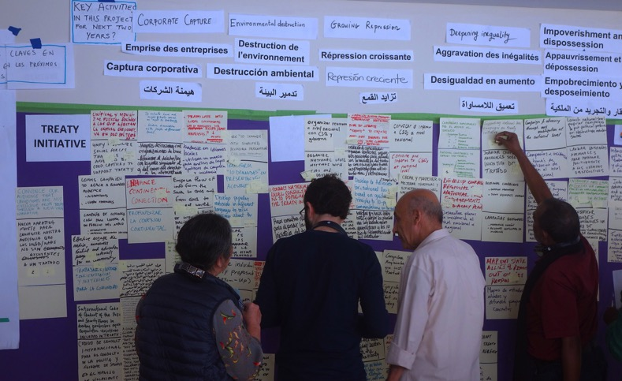
Several themes emerged from CAWG members concerning the future direction of the Corporate Capture Project, in light of explicit inclusion, in the Common Charter for Collective Struggle, of corporate capture as a common global condition affecting the enjoyment of ESCR globally. Suggested ideas included: increased support at national level for research and documentation (including developing resources members can use to identify and document corporate capture cases); developing and distributing materials to simplify and popularize the concept of corporate capture at local and national level, strong campaigning efforts to denounce corporate capture; various legal strategies (e.g. developing guidelines to preserve judicial independence).

Regarding the Treaty Initiative Project, members suggested a number of specific activities, including turning the Ten Key Proposals for the Treaty into simplified materials for mobilizing local and national support, as well as encouraging members involved in the Corporate Capture Project to bring their analysis and advocacy skills into efforts to support the treaty. The most widely supported idea was to intensify national activities via community education, public campaigning, lobbying of governments and facilitating popular mobilization efforts. These ideas were connected to the emerging Network-wide objective to ‘mobilize to demand strong institutions, norms, and accountability to ensure access to justice, effective remedies, and implementation.’ Similarly, CAWG prioritized ongoing engagement in the development of the forthcoming General Comment on business activities and economic, social and cultural rights by the UN Committee on ESCR. The General Comment provides an important and more immediate space to advance priorities for the text of the treaty, and could therefore be used as an authoritative advocacy tool in the treaty negotiations.

Members agreed again that Strategic Case Support is an integral part of our collective work, and echoes the emerging Network objective to ‘strengthen the credibility and capacity of defenders’. Members noted that documentation is important across all CAWG activities and, more specifically, discussed how to evolve the documentation tool already developed by members in partnership with the Business and Human Rights Resource Centre.

Members supported the need to strengthen an intersectional analysis in the working group. In order to begin this process more systematically, members agreed to extend an invitation to the Women and ESCR Working Group to provide critical input into the CAWG planning process for 2017 – 2018.

Monitoring

Leading up to the GSM it was recognized that most, if not all, projects in the Network involve monitoring in some capacity (whether at the stage of human rights impact assessment, monitoring and reporting on ongoing situations, use in litigation and other forms of advocacy to achieve redress or transformation, evaluation of trends and causal relationships, or otherwise). For that reason, Monitoring Working Group (MWG) members chose to spend the morning with various other working groups, to identify and explore possible connections with existing and proposed projects/activities across the Network.

During their afternoon discussions, the MWG members proposed the following key action areas, with associated specific projects/activities:

- Confront weaknesses and biases in human rights accountability mechanisms: Members focused primarily on the need to strengthen community-based monitoring, recognizing that ‘who’ undertakes the monitoring of ESCR is just as important as exactly ‘what’ is being monitored. In pursuing such an approach, members explicitly noted the need for meaningful connection with communities particularly affected by systemic and/or significant ESCR issues. Members also considered the possibility of developing ESCR-Net monitoring position papers on topical issues, as well as the need to ensure implementation of existing monitoring frameworks for ESCR.
- Ensure that States publish better quality, more disaggregated data: Members discussed the continuation of an existing MWG project that focuses on the gathering of recommendations made by UN treaty bodies about the collection and provision of disaggregated data by States. Following analysis of the collated information, members will consider appropriate advocacy action to take to encourage a progressive shift in treaty body practice, leading to corresponding advances in monitoring practices by States and other stakeholders.
- Strengthen working group/Network-wide actions through monitoring strategies: Members expressed strong enthusiasm for collaborating with other working groups and in Network-wide initiatives to strengthen existing and emerging projects through applied monitoring expertise and sharing of tools, resources and developments. While a number of ideas for specific projects/activities were proposed, the most popular included: the convening of online methodology workshops to propose and develop monitoring strategies for particular Network projects; and the capacity-building of Network members to undertake analysis necessary to confront systemic global challenges (for example, in relation to fiscal policy, monetary policy, progressive realization of ESCR, and inequality). Related to these proposals, members also suggested a mapping of the monitoring expertise of the MWG and the monitoring capacity building needs of Network members, as well as the continued strengthening of the MWG website resources, particularly as related to ongoing focus areas of the Network such as corporate accountability.
It is noted that the proposed areas of focus correlate in particular to the emerging shared objectives relating to communication with affected communities, the operationalizing of an intersectional approach across the Network, and the development of strong institutions and accountability practices.

Economic Policy

In line with the analysis and call to action of the Charter, members foremost prioritized deepening investigation and analysis of the global economic system via the human rights framework and informed by grassroots struggles, identifying and amplifying alternatives, in support of a campaign or collective action. In shaping and prioritizing this action area, members combined proposals that focused on a “global campaign including investigation, advocacy, and communication in order to reposition human rights as norms superior to economic agreements” or similarly a “campaign to attack what is behind all the issues represented in the Network – the current system of global capital,” which “should be guided by the interests and demands of persons and organizations directly affected by human rights violations” and “build not so much on existing NGOs/Networks but struggles [working to] lift them up, build support for them, and share their links to each other and the global economic system,” while “crowd-sourcing alternative economic policies and practices.” A few members expressed a reluctance to move too quickly to taking up specific issues, policies or institutions, emphasizing that these serve or are part of a wider economic model.

In beginning to articulate specific activities and intended impacts under this action area, several members advocated for building an analysis based on specific grassroots struggles of ESCR-Net members, tracing threats of dispossession, impoverishment and related human rights violations to specific policies and institutions and ultimately to the wider economic system. While serving to connect these struggles and deepen a common analysis, this approach would ideally lead to identifying clear advocacy targets and coherent strategies for collective action. This would also likely involve popular communications efforts, connecting and amplifying grassroots struggles, articulating alternatives potentially in partnership with progressive economists and new alliances, and ultimately shifting the terms of debate or narrative towards the primacy of human rights.

Several members also expressed interest in collectively addressing the shrinking role of the State and civil society due to international financial institutions, including the International Monetary Fund. In beginning to consider specific activities/advocacy efforts related to this action area, members proposed undertaking a human rights assessment of international financial institution conditionality focused on austerity and tax policy and creating an IMF Watch to challenge harmful economic policies across the Network in times of deepening austerity. Multiple members also expressed their interest in each of the following potential action areas, including: promoting the role of public authorities in fulfilling ESCR and resisting privatization, reclaiming the concepts of public utility or general interest as central to human rights and alternative economic approaches, and taking action regarding the environmental impact of the neoliberal model, while a couple noted intersecting advocacy on extraterritorial obligations and corporate capture as possible entry points or spaces for cross-working group collaboration. A couple highlighted the Agenda 2030 context, which is framing discourses and work on inequality and poverty. Finally, some recalled the recent mapping of members and related webinars, which also foregrounded a systemic critique of the dominant economic model via the human rights framework and then pointed to specific manifestations of the global economy, including trade and investment, privatization and public-private partnerships, and infrastructure, energy and extractives, as well as the strong desire to amplify or articulate alternative models. As ESCR-Net looks to hire a program coordinator focused on economic policy to support collective work, members noted the need to continue this strategic dialogue.

VI. Ensuring a safe space for human rights work

Remembering members who could not attend

Several active ESCR-Net members were unable to attend due to serious threats to their security in connection with their human rights activities, illustrative of broader patterns of repression against the activities of human rights defenders (HRDs) globally.

In a video address during the opening ceremony, Gustavo Castro, in absentia, wished his fellow members well and reiterated the importance of Network solidarity. Castro was the subject of urgent actions undertaken by ESCR-Net in March 2016, following the assassination of Honduran human rights defender, Berta Cáceres, an attempt on his life, freedom of movement restrictions, and ongoing security threats.
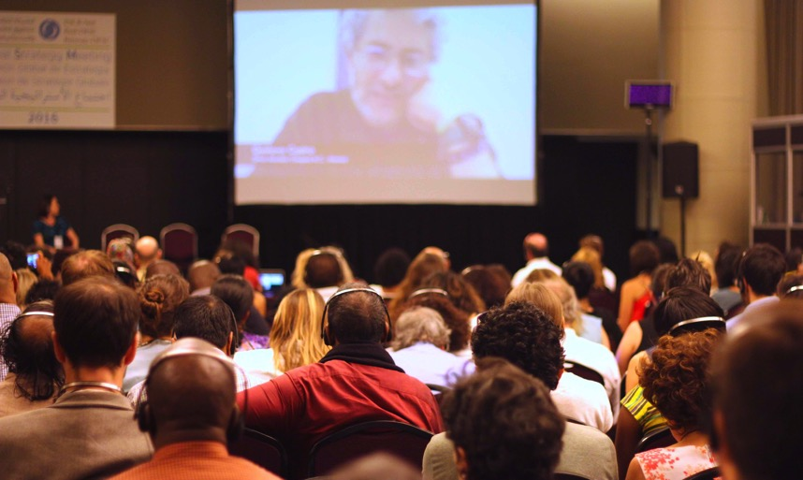

Also absent was Cesar Yovany Bernardez Herrera of the Organización Fraternal Negra de Honduras (OFRANEH), who was arrested and beaten—together with four other members of OFRANEH—while attempting to board the airplane for Buenos Aires. The youth leader was coming to the GSM on behalf of the Honduran Garifuna indigenous movement, which is working to defend ancestral territories and resources from the expansion of corporate ventures being imposed without consent.

Members also noted the absence of Alfred Brownell, founder of Green Advocates International, Liberia’s first public-interest environmental law and human rights organization. Following several years of mounting threats in reprisal for his human rights advocacy work, he and other Green Advocates colleagues were targeted with arrest warrants in November. Similarly, Eang Vuthy of Equitable Cambodia was unable to attend due to recent efforts to criminalize members of his staff, apparently in connection with their work to defend and promote the human rights of communities affected by sugar cane concessions across Cambodia. Finally, ESCR-Net’s former Board Chair, Hossam Baghat, remains the subject of a travel ban and asset freeze in a case targeting key human rights organizations and some of their individual founders in Egypt.

In recognition of the serious threats affecting HRDs working to advance ESCR, the Advisory Group to the System of Solidarity (SOS) met on the morning of Tuesday, November 15 to advance plans to strengthen that System in the coming period.

Training on security and protection

Following the conclusion of the GSM, 35 members stayed joined an optional security training and informational session about ESCR-Net’s SOS, facilitated jointly by two members of the SOS Advisory Group. Through general discussion and a practical exercise, members shared observations about their daily routines, reflected on the security risks and vulnerabilities which they face in their lives and work, and considered strategies for safety and well-being for HRDs working to advance ESCR

VII. Next steps
In the final session of the GSM and in subsequent evaluation and exchange, members attested to the importance of an in-person meeting to deepen a common analysis, strengthen alliances and relationships of solidarity, collaboratively shape the future direction of the Network and commit to collective action with one another.
In this regard, the immediate next steps will include:
- Developing and finalizing Working Group two-year action plans: via ongoing discussions within and across Working Groups, members will agree on plans for collective action in early 2017.
- Deepening coherent, coordinated joint action to advance ESCR: through the Working Group action-planning process, and as an evolving practice, the secretariat will work with members to identify and enhance connections across the Network, with a view to strengthening collaboration between working groups and across ESCR-Net. Improved coordination across working areas, in response to the shared analysis contained in the Charter, will facilitate consideration of collective actions for the coming period; including a potential campaign. In the first part of 2017, members will be invited to join planning conversations to articulate proposals for coordinated collective work for the coming period.
- Strengthening an intersectional gender perspective: again, beginning with the Working Group action planning process, and as an evolving practice, the secretariat will work with members – particularly but not exclusively the Women and ESCR Working Group – to develop practices across the Network that encourage all members to integrate an intersectional gender perspective, attentive and responsive to the disproportionate impacts of ESCR violations on women, and the lived experiences of differently situated people around the world.
- Evolution of activities from the concluded campaign to ratify the OP-ICESCR: With thanks to the Steering Committee for the Campaign for its leadership in achieving the significant impacts noted above, the secretariat will update the website on the Campaign and ensure resources remain available for continued national and regional advocacy for ratification. The individuals and organizations that assumed leadership will continue to guide efforts to secure access to justice for ESCR and inform new collective efforts across the Network, including cases and interventions under the OP-ICESCR and ongoing engagement with the Committee on ESCR and the Group of Friends of ESCR.
- Bolstering security for human rights defenders: Under the guidance of members comprising the Advisory Group for ESCR-Net’s System of Solidarity, members will collaborate via advocacy initiatives, capacity-building, access to resources and further outreach to enhance protections available to human rights defenders affiliated with the Network, while addressing some of the root causes behind the threats they face in reprisal for their human rights activities.
- Developing a Strategic Plan to guide ESCR-Net’s work for the coming five years: Based on the progress made at the GSM, the Board, with the support of the secretariat, will work over the next few months to develop a draft strategic plan – including related elements of institutional development – for review and comments from members. This strategic plan will build on the Common Charter for Collective Struggle and draw foremost on the work accomplished during the GSM towards defining shared objectives, inviting input of those who could not be present, and drawing on action planning and ongoing dialogue in working groups.

Annex A. Global Common Conditions

Annex A1. Inputs to the Common Charter aggregated from five small groups

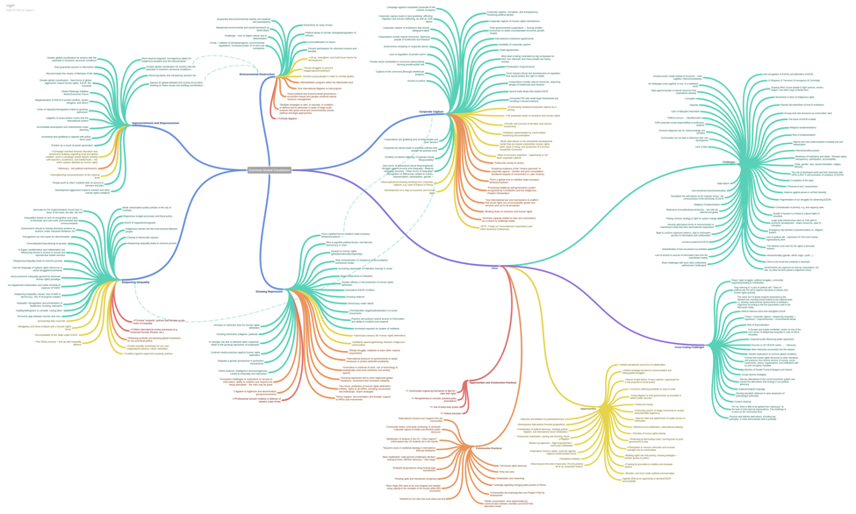

Annex A2. Inputs related to impoverishment and dispossession aggregated from five small groups

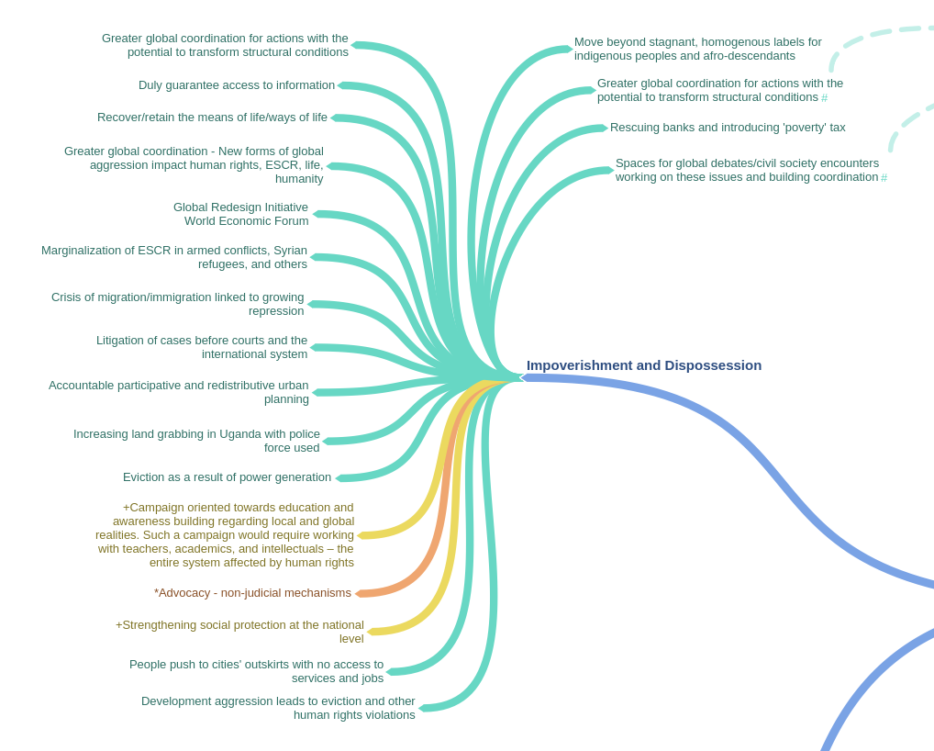

Annex A3. Inputs related to corporate capture aggregated from five small groups

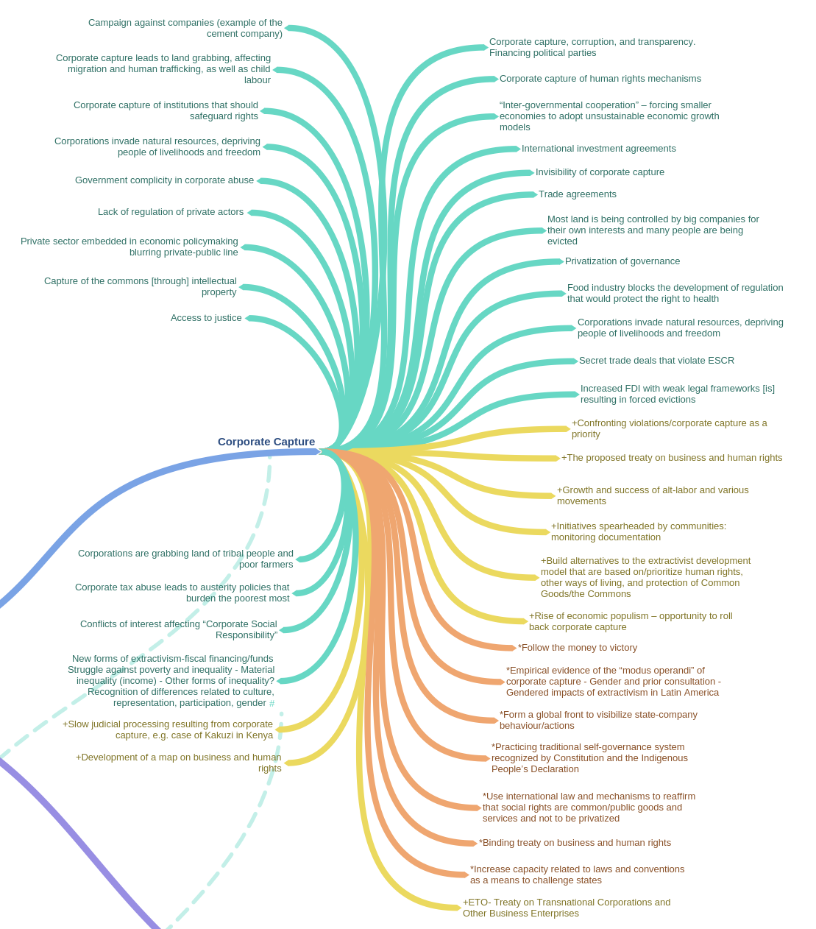
Annex A4. Inputs related to deepening inequality aggregated from five small groups

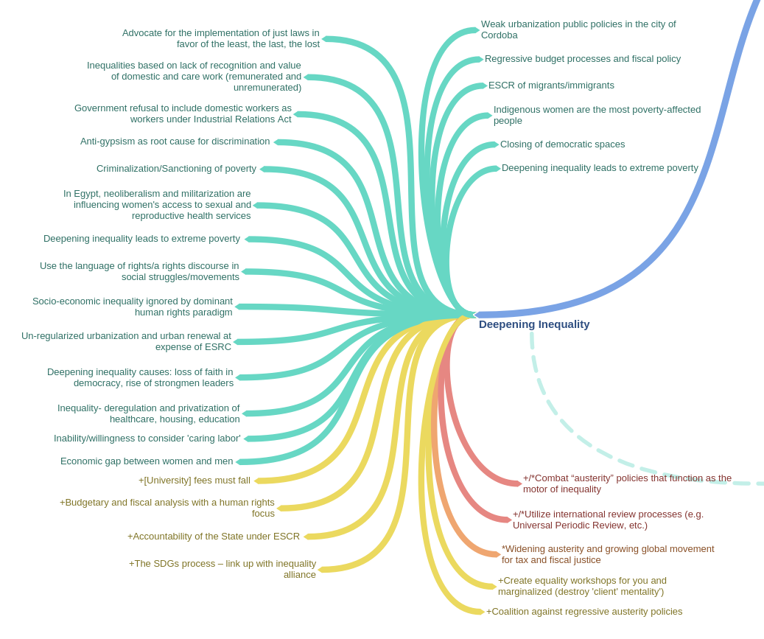

Annex A5. Inputs related to environmental destruction aggregated from five small groups

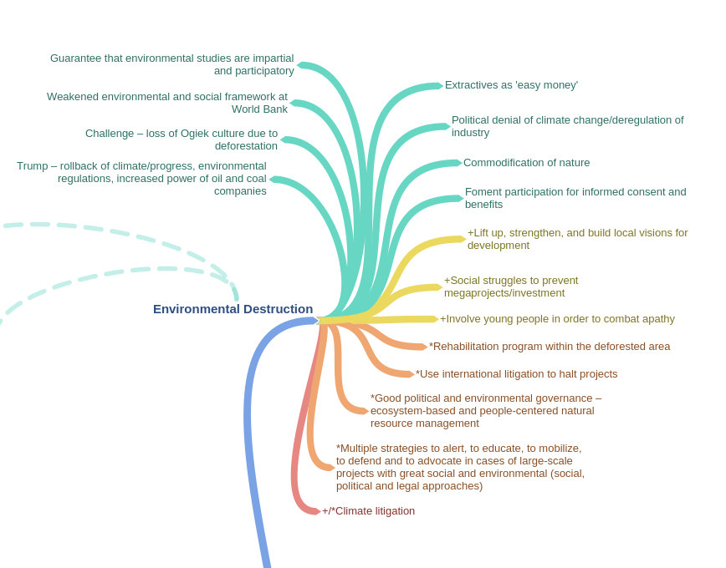

Annex A6. Inputs related to growing repression aggregated from five small groups

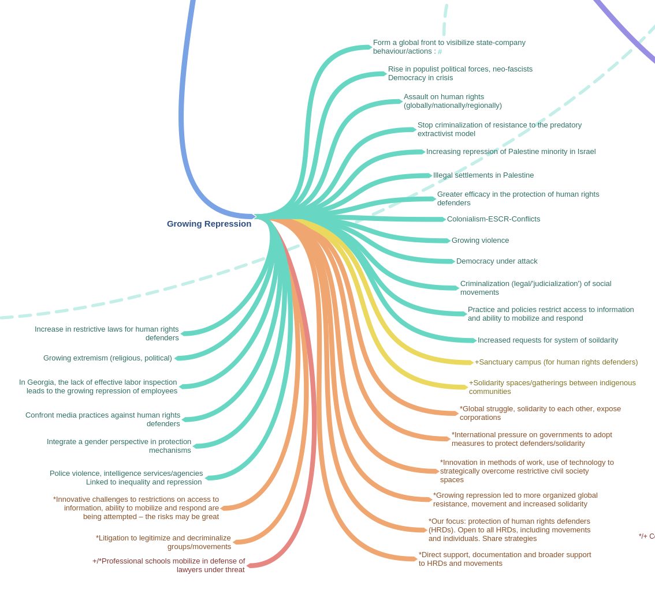

Annex A7. Inputs related to other challenges aggregated from five small groups

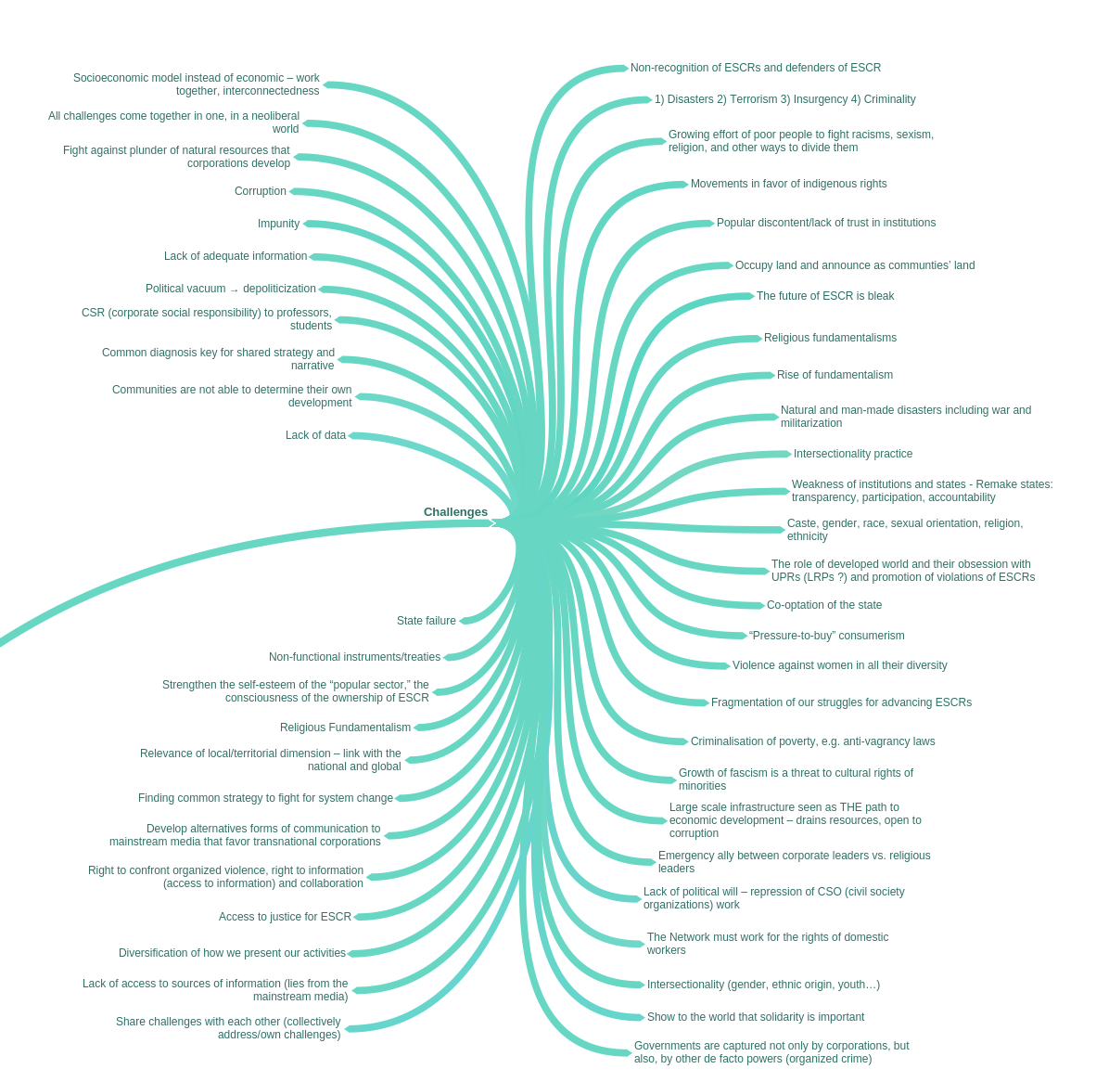

Annex A8. Inputs related to opportunities and constructive practices aggregated from five small groups

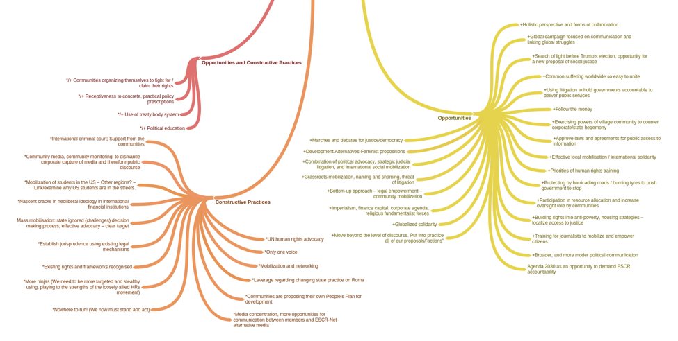

Annex A9. Inputs related to all global conditions aggregated from five small groups

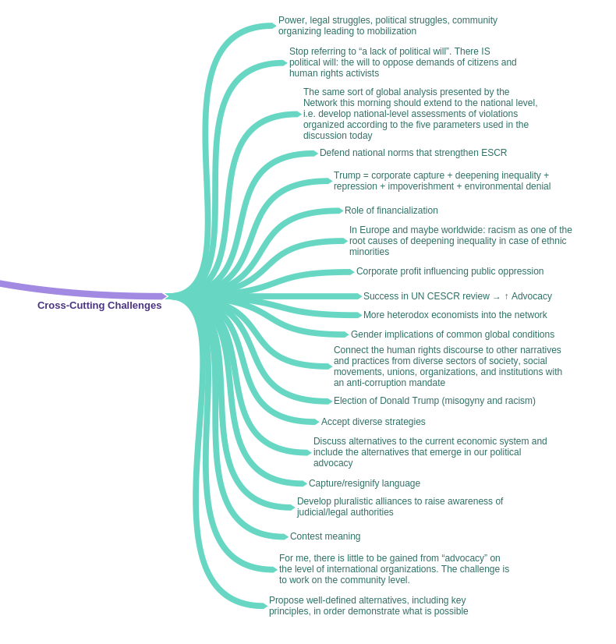

Annex B

What should we work on together to advance ESCR over the next five years?

Annex B1. Provisional shared objectives from plenary discussion

Option 1: Intensify cross-network and innovative investigations, communication, and strategic actions. | Improve and strengthen internal synergies and alliances between movements, promoting perspectives based on gender, ethnicity, race, caste, disability, and the intersectionality between these. | Option 1: Mobilize to demand strong institutions, norms, and accountability to ensure access to justice, effective remedies, and implementation. | Further develop, consolidate, and popularize a shared vision as an alternative to the dominant socio-economic paradigm, from an inclusive and gender perspective. | Option 1: We need to strengthen the impact and effectiveness of the network through communication with affected communities to fully realize ESCR. | Strengthen the credibility and capacity of defenders (members, allies, women) and act to guarantee their protection through a system of solidarity
Option 2: Develop innovative strategies of communication, mobilization and knowledge building and litigation for the justiciability and enforcement of ESCR. | Alternative 1 (Offered in Plenary):  Strengthen the internal synergy and sustainability of the Network, promoting a gender, ethnic and racial perspective, and establish alliances with other movements. | Option 2: Strengthen and expand institutions, norms and accountability to ensure implementation and enforcement. |  | *Alternative English Translation (Offered in Plenary): We need to consolidate the impact and effectiveness of the network through popular communication and alliance-building with other movements.
Alternative 2 (Offered in Plenary):
We should strengthen cross-cutting synnergies with ethnic, racial, gender, environmental and other perspectives, in a sustainable manner.
Employ multiple levels of intervention strategies across the network which may include campaigns, protests, advocacy, and strategic litigation. | Integrate race, class, gender, caste and all other forms of discrimination and the intersectionality among them in all our work. | Promoting access to justice through strategic litigation, connection of social movements and all WGs. | Demand budgets, as well as labor and social policies with a gender perspective. | Broaden and deepen the network, its alliances, narratives, and dialogues. | Strengthen systems of solidarity and protect members under threat
Investigate ESCR violations at the national and regional level, creating accessible tools for action. | Strengthen internal coordination, communication, and capacity. | Strengthen institutional and normative frameworks of ESCR. | Develop alternative concepts to respond to the dominant economic discourse. | Broaden coordination/consensus on ESCR through the exchange of knowledge and experiences of struggles to demand rights. | Strengthen solidarity and protection mechanism for members and allies at risk.
Develop an innovative joint campaign via ESCR-Net based on concrete cases. | We should build the network in a strategic and sustainable way. | Diversify legal and judicial strategies to guarantee/reinforce the protection and justiciability of ESCR. | Articulate and unleash a global campaign to confront current socio-economic and development policies and advance alternatives. | Visibilize and connect struggles through alternative ESCR media. | Promote the protection and credibility of HRDs (WHRDs) and demand as well as contribute to a safe environment for their work.
We should, within countries and across borders, monitor and advocate on the public/private economic relationships that contribute to abuses. | Adopt and implement cross-cutting axes with a holistic perspective, including gender, ethnicity, and environmental rights. | Create a global campaign on the justiciability of ESCR. | Consolidate (and popularize) a common vision (and generate alternative proposals) from a feminist perspective to realize ESCR. | Actively engage other movements and new audiences to strengthen work for ESCR. | Consolidate mechanisms of protection and strengthen the capacity of ESCR Defenders.
Create a strategy of communication for a wider audience in favor of ESCR. | Improve internal and external synergies of work, ensuring the sustainability of members and the network itself. | Strengthen engagement of ESCR-Net members including social movements, in international and regional mechanisms.
Evidence-based research, documentation, and communication with members and beyond to guide rights-based advocacy. | Create and operationalize systems, processes and working groups and ensure an intersectional approach across the network (indigenous, gender, race, people with disability, youth, ethnicity), | Build collective capacity to strengthen implementation and enforcement of existing ESCR framework.
Identify key issues/trends/themes for joint actions in defense of ESCR. | We should strengthen the skills and capacities with the network by promoting exchanges among the WGs, social movements and other relevant actors beyond the network. | We should ensure that states commit, ratify, implement, and realize ESCR in law and practice.
Intensify strategies for demanding ESCR.

*Cards not included in clusters above: “Visibilize and support rights of domestic workers”, “Expand public education and local mobilization for ESCR”, and “Defend ESCR in areas of armed conflict and occupation”

Annex B2. Provisional shared objectives from Group A

Strengthen internal coordination, communication and capacity | Strengthen engagement of ESCR-Net members including social movements in international and regional human rights mechanisms | Expand public education and local mobilization for ESCR | Title version 1: Consolidate our common vision and generate alternative proposals from a feminist perspective to realize ESCR  Title version 2: Consolidate and popularize a common vision from a feminist perspective to realize ESCR | Title version 1:  Identify key issues/trends/themes for joint actions in defense of ESCR  Title version 2: Employ multiple levels of intervention strategies across the network which may include campaigns, protests, advocacy, strategic litigation | Strengthen solidarity and protection mechanisms for ESCR-Net members and allies at risk
Drawing from existing experience and work of members into themes of the Network | Making accountability mechanisms more accessible | Popularize ESCR – turn words into visuals | Bringing our vision into focus | Show how particular cases are part of global trends | Inter-member fellowships for activists under threat
Better communication and Identify who is in the Network and who does what | Improving UPR/treaty body advocacy/revisiting collective strategy | Strengthening, expansion and integration of movements | Popularize common vision | Strengthen monitoring, documentation and advocacy on the impact of corporate capture | Accompaniment and protection for defenders
Linking, learning and advocating inside and outside the Network | Creation and ratification of UN instruments (OP-ICESCR, Treaty) | Outreach to other constituencies (eg. migrants, labor, climate change movements) | Strengthen alternative proposals | Collective protests against corporate crimes | Clear strong support to human rights defenders
Improve internal communication |  | Active inclusion of marginalized youth | A feminist approach to ESCR | Joint campaigns on common issues | Expand the issues that trigger solidarity and be more creative in how we mobilize
Strengthen capacity through monitoring relationships |  |  |  | Develop a campaign on how resource distribution impacts human rights
 |  |  |  | Transnational struggles against TNCs
 |  |  |  | Support implementation of (national) ESCR court decisions
 |  |  |  | Provide amicus/third party interventions
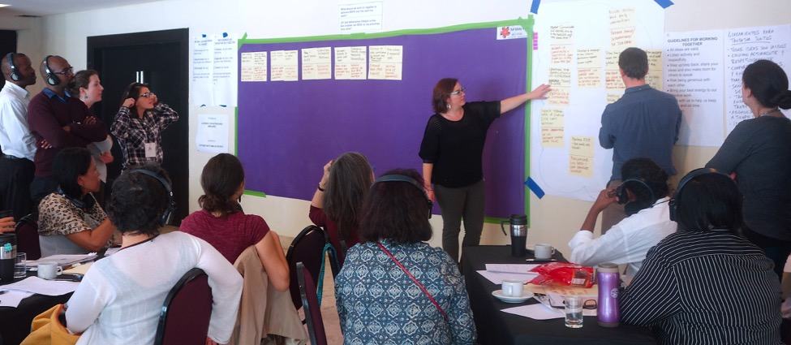
Annex B3. Provisional shared objectives from Group B

We should ensure that States commit to, ratify, implement and realize ESCR in law and in practice | Promoting access to justice through strategic litigation, connection of social movements and all WGs | Evidence-based research, documentation and communication within members and beyond to guide rights-based advocacy | We should promote the protection and credibility of human rights defenders (HRDs) (including women human rights defenders - WHRDs) and demand and contribute to a safe environment for their work | Integrate race, class, gender, caste, and all other forms of discrimination, and the intersectionality among them in all our work | We should, within countries and across borders, monitor and advocate on the public/private economic relationships that contribute to abuses | Broaden and deepen the Network, its alliances, narratives and dialogues | We should strengthen the skills and capacities within the Network by promoting exchanges among WGs, social movements, grassroots groups and other relevant actors beyond Network
Monitoring and advocacy of the Paris Agreement | More strategic support: litigating cases, community struggles | Evidence-based research, documentation and communication (members and beyond) | Ensure protection and increase credibility of HRDs, including WHRDs | Integrate race, class, gender, caste and other forms of discrimination in all our work in an intersectional way | Within countries and across borders, focus on the public/private economic relationships that contribute to abuses (ETOs) | Grow the network by popularizing the ESCR-Net vision, shaping broader dialogue on ESCR through promotion of member stories, action, case studies | Capacity building and exchange among social movement and grassroots members.
Reclaim, optimize local and international HRIs (human rights institutions) | Deepen connection between social movements and litigation groups | Strengthen the collection, exchange and advocacy-use of data among individual members and the Secretariat | Support HRDS, WHRDs and communities who are at risk working on economic, social and cultural rights | Stronger women’s rights analysis across ESCR-Net | Adoption of treaty on Business and Human Rights | Broaden and deepen alliances and narratives (sex workers, rural women, trans) | Capacity building of members
Keep close eye on Sustainable Development Goal (SDG) implementation (re: corporate capture) | Promote access to justice at national and international levels (UN, regional HR systems, OP-ICESCR) | More joint submission with wide support from allies | Preventative work on HRDs along with reactive and solidarity actions | Ensure work against intersectional discrimination is reflected in the work of the Network | Mobilize for treaty (CAWG)
Advocacy on getting States to recognize and implement ESCRs in national law and public policy (including Sustainable Development Goals – SDGs) | Double efforts for the ratification of the ICESCR and OP-ICESCR | Effective communication and sharing amongst members | Tap more lawyers to defend social movement leaders and HRDs
Collective action on economic policy i.e. tax, etc. | Strategic research, litigation

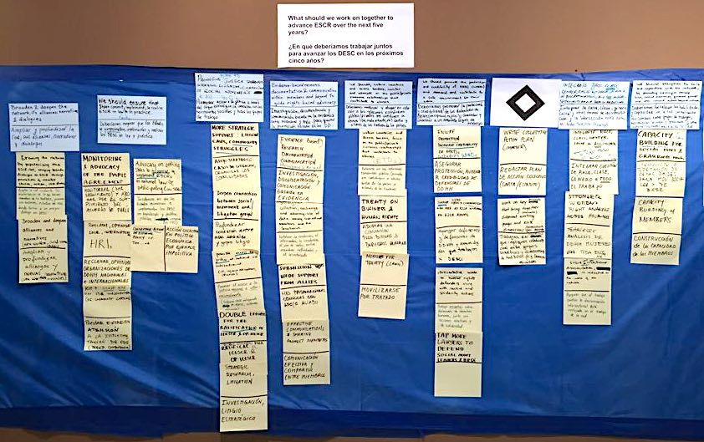
Annex B4. Provisional shared objectives from Group C

Strengthen institutional and normative frameworks on ESCR | Articulate and unleash a global campaign to confront current socio-economic and development policies and advance alternatives | Create and operationalise systems, processes and WGs and ensure an intersectional approach across the network (gender, race, disability, youth, indigenous people, sexuality, ethnicity) | Build collective capacity to build and strengthen implementation and enforcement of existing ESCR framework | Visibilise and connect struggles through alternative ESCR media | Strengthen systems of solidarity and protect members under threat | Visibilise and support rights of domestic workers | Strengthen the connection / coordination between movements
Build jurisprudence around ESCR through effective use of domestic, regional and international mechanisms | Elevate political cost of existing development models and provide alternatives | Create internal structures for intersectional approach for all network projects | Build our collective capacity to support communities to access remedy for violations | Listen to and lift the demands of affected people in their own languages | Continued and strengthened ability to respond to needs of HRDs, coordinate response, activate network | Use CEDAW and CESCR to advance rights of domestic workers | Increased membership of peoples’ movements, and collaboration and alliances with other movements
Community capacity building for corporate accountability | Learn to use popular culture to communicate demands and concerns to large numbers of people | Mapping best practices from members’ work – share lessons / expertise / opportunities | Drive implementation of Spain [OP-ICESCR] case and other ESC cases | Amplify messages (members’ struggles, work) using media – build capacity to raise awareness | Protect ESCR defenders (individuals, communities, movements) | Solidarity actions in key countries to demand implementation ILO standards domestic work | Link to other movements (black lives matter, youth etc), and support other struggles
Present a case on women’s ESCR (OP-CEDAW / OP-ICESCR) | International school campaign for ESC rights | Create a job-swap program with members | Explore with SR Housing accountable, participative, redistributive urban planning
Increase focus on national level laws, policies, advocacy to enhance ESCR | Dialogue and debate to develop alternative economic and development models | Establish a working group on indigenous peoples’ issues
Increase use and transformation of international legal frame for ESCR protections | Concentrated global campaigns to challenge global ESCR issues
Continue fighting for a binding treaty on CA and national level policies / laws | Create 2-page [brief] narrative on systemic and socio-economic systems
Develop a common strategy to strengthen international human rights bodies | Expose use of racism, sexism, nationalism and xenophobia to divide people who have a common interest in fighting economic oppression
Establish regional focal points to support ICESCR / OP-ICESCR ratification campaign | Share and develop human rights-respecting economic policies
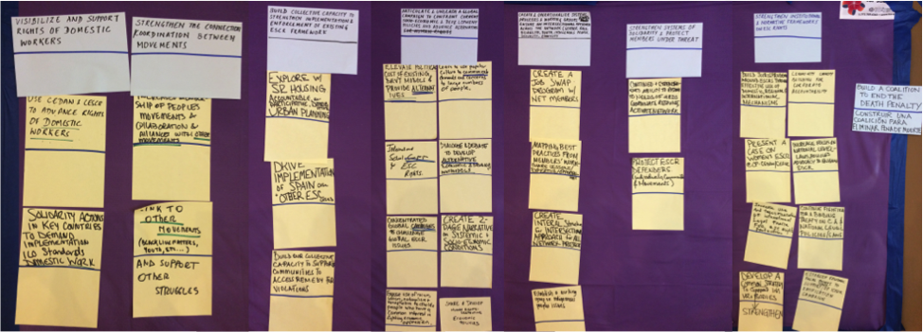

Annex B5. Provisional shared objectives from Group D

Improve internal and external synergies of work, ensuring the sustainability of members, and the network itself | Investigate ESCR violatios at the national and regional level, creating accessible tools for action | Expand awareness on ESCR through the exchange of knowledge and experiences of struggles to demand rights | Diversify legal and judicial strategies to guarantee/reinforce the protection and justiciability of ESCR | Adopt and implement cross-cutting axes with a holistic perspective, including gender, ethnicity, and environmental rights | Create a strategy of communication for a wider audience in favor of ESCR | Develop innovative joint campaign actions based on concrete cases | Develop alternative concepts to respond to the dominant economic discourse
ESCR-Net as a platform for struggle across the diversity of the Network | Develop monitoring and research strategies to reduce gaps in information on ESCR | Training and education for actions to promote ESCR | Develop legal strategies that go beyond the State to address the role of companies | Rights focused on the environment and mother earth as a foundation for protecting ESCR | Implementation of an ESCR-Net communication strategy | Annual day of mobilization on ESCR around the world | Intensify efforts to strengthen an alternative discourse utilized by ESCR-Net
Strengthen links to other groups and networks (food, cities, environmental…) | Compilation of materials and declarations on ESCR from UN and regional mechanisms | Training and empowerment of communities, social movements, and defenders | Foment the justiciability of ESCR on national, regional, and international levels | Adopt a holistic perspective: gender (not just the Working Group, ethnicity, indivisibility | Develop better communication strategies/narratives on human rights as a way to link to other movements/groups | Build a counter-narrative makes explicit State-company collusion, as well as the acceptance of sacrificial zones | Promote the inclusion/prioritization of human rights in development policies as well as legal frameworks and budgets
Permanent strategic alliances between NGOs/social movements, ESCR-Net, and others | Compile cases, conflicts and systematize/organize (a mapping) | Build awareness and commitment among rights holders and duty bearers | Support members’ monitoring efforts and advocacy with UN treaty bodies and regional mechanisms | Integrate analysis on the influence of transnational companies in all working groups | Adopt a new communication strategy, more modern, etc. | Develop a global campaign based on concrete cases in distinct regions
Broaden and strengthen the Network: working groups and national and regional coalitions | Monitoring for current projects (or future projects) based on the use of alternative benchmarks (frameworks) relevant to ESCR | Opportunities to exchange of experiences, struggles, research, and knowledge | Presentation of emblematic cases in national and international legal spaces
Build strategies to denounce violations and demand ESCR that involve multiple actors (NGOs, communities, public opinion) | Dissemination of current realities of ESCR by country
Promote the sustainability of ESCR-Net and its members | Monitor international standards promoted by ESCR-Net
Improve communication, connections/coordination, and create synergies between members working on common issues

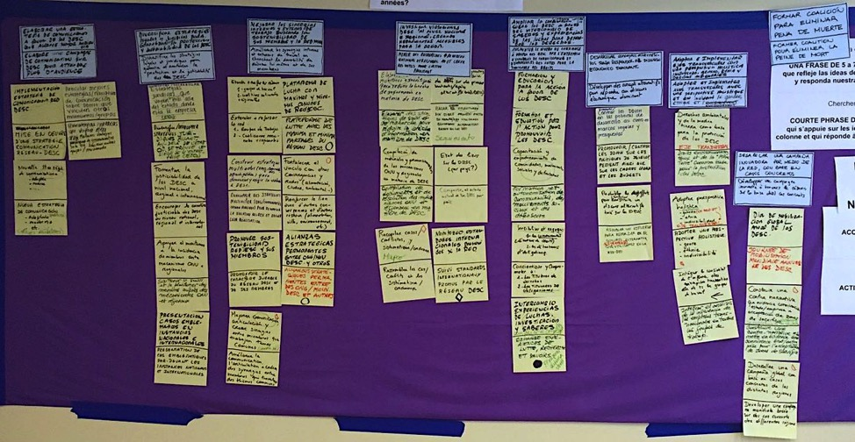

Annex B6. Provisional shared objectives from Group E

Intensify strategies for demanding ESCR | Create a global campaign on the justiciability of ESCR | Build the network in a strategic and sustainable way | Consolidate mechanisms of protection and strengthen capacity building for ESCR defenders | Budgets, as well as labor and social policies that foreground a gender perspective | Defend ESCR in areas of armed conflict and occupation | Other
Offer support on reports for HR Committees | Justiciability campaign | Database/databank on ESCR | Training for ESCR defenders and demand authorities receive ESCR training/education | Incorporate women’s economic participation (unremunerated work) as a key issue in our work | Link ESCR to International Humanitarian Law (IHL) in armed conflicts | Defend and promote alternative communication media with an emphasis on ESCR
Jointly strengthen mechanisms for demanding ESCR | Define key issue of a campaign, e.g. a campaign building on the 70th anniversary of the Universal Declaration of Human Rights (UDHR) | Promote opportunities for exchanging/sharing experience and knowledge  Sharing best practices in the defense of ESCR | Resources and training/education dedicated to security ( Resolution on Defenders) | Petition the WTO to create a convention on gender-based violence in the workplace | Highlight the economic dimensions of the Israeli occupation in Palestine territories, focusing on Palestine natural resources | Reflection on, and promotion of development alternatives – recognition of local economies
Strategic litigation before UN CESCR for one year | - Global mobilization in defense of ESCR:  Local struggles  Corporate capture  Other spaces  Governance  Work on treaty mechanisms  Migration | Involve working group members in discussions (google-groups)  Agile responses of the Network to political and economic changes on an international level | Strengthen protection mechanisms for human rights defenders | Gender-sensitive budgets (gender perspective)
Platform for complaints regarding ESCR violations | Global movement to respond to current and future challenges Anti base erosion and profit shifting (BEPS)/austerity  Tax/redistributive justice | Build capacity of members (e.g. fundraising, strategic litigation, etc.) | Democratize the union movement – strengthen capacity to represent the movement and to negotiate
Lobbying for a Treaty on Business and Human Rights
Actions by working groups to promote ratification of the OP-ICESCR

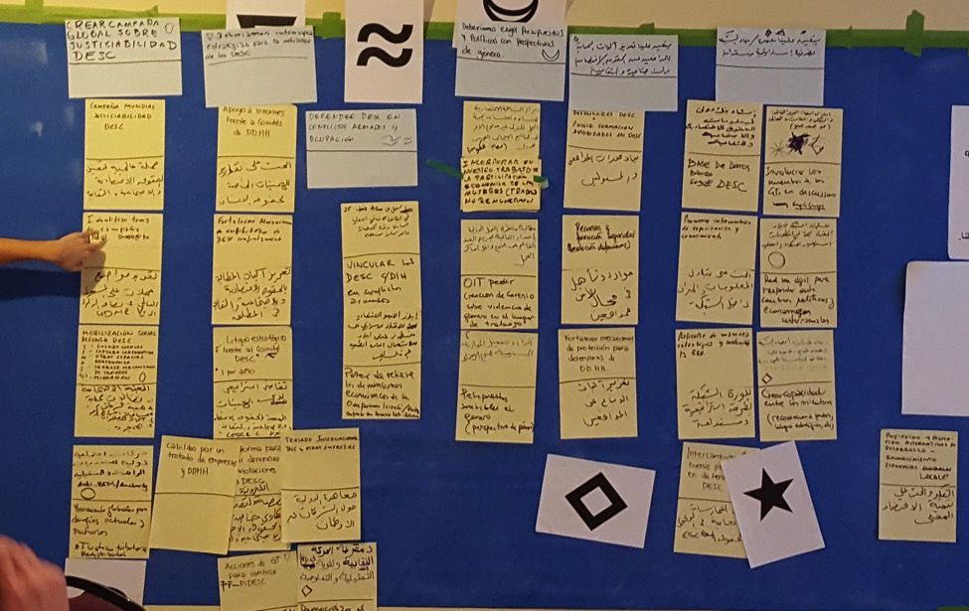

ESCR-Net –International Network for Economic, Social and Cultural Rights unites over 280 NGOs, grassroots groups, and advocates across 75 countries, facilitating strategic exchange, building solidarity, and coordinating collective advocacy to secure social and economic justice through international working groups.

For more information, please visit www.escr-net.org

Photo credit: Nicolás Schujman

Consisting of member representatives from: ACIJ, Argentina; CELS, Argentina; ANND, Lebanon; FIDA-Kenya, Kenya; FI, Switzerland; ILSB, Mexico; Kairos, USA; LRC, South Africa; NAFSO, Sri Lanka; Video Volunteers, India.
FOCO and FUNDEPS, together with ACIJ and CELS.
Melona Daclan Repunte of Defend Job, Philippines

